**___________________________________________________**

Business Online Postage Application

High Level Design (HLD)

**___________________________________________________**

Table of Contents

1. Introduction 3

1.1 General Points 3

1.2 Business Rules 3

1.3 Content Pages 3

1.4 Error Handling 3

1.5 Request Expiration 3

1.6 Accessibility 4

2. Legend Diagram 5

3. Session Data Exchange Overview 6

4. Analytical Tagging 7

5. Domain Models 8

5.1 Fulfillment Requests / Responses Domain Model 8

5.2 Spoil Requests / Responses Domain Model 9

6. State Models 10

6.1 Order State Model 10

6.2 Order Line State Model 10

7. Activity Diagrams 12

7.1 User Activity Diagrams 12

7.2 Integration Tier Activity Diagrams 12

7.2.1 Process / Expire Fulfilment Request Activity Diagram 12

7.2.2 Process Spoil Request Activity Diagram 13

8. Enterprise Integration Diagrams 14

8.1 Process / Expire Fulfilment Request E.I. Diagram 14

8.2 Process Spoil Request E.I. Diagram 14

9. Business OLP User Journeys 16

10. Monitoring and Logging 17

11. Data Retention 18

APPENDICES 19

Appendix A: Abbreviations and Glossary 20

Appendix B: Document Control 21

Appendix C: Reference Documents 22

Appendix D: Screen Validations 23

THIS DOCUMENT CONTAINS **XY** PAGES INCLUDING TITLE PAGE

# Introduction

## General Points

None at this time.

## Business Rules

All business rules and logic are stated in this document, along with the screens they are associated with.

## Content Pages

## Error Handling

The method of presenting both fulfilment and refund outcome narrative messages to the user will ensure that technical root causes are not exposed.

## Request Expiration

In the event of a significant volume of requests (fulfilment or refund), or a significant slow-down / non-availability of third-party endpoints, request expiration (via a configurable timeout period) will prevent “stale”/redundant requests from being processed.

Integration-Tier responses will facilitate the dissemination of this “request expired” information to the eBusiness Tier and beyond.

## Accessibility

No requirements at this time.

# Legend Diagram

The Legend diagram provides a high-level view of the main platform components affected by this design:



# Session Data Exchange Overview

None at this time.

# Analytical Tagging

None at this time.

# Domain Models

Communications with the Integration Tier is by means of the Fulfilment Request / Response and Spoil Request / Response messages. The details of the requests and the resulting responses are encoded in XML bodies.

## Fulfillment Requests / Responses Domain Model

This section might need updating as we’re going to have to add fields to this. Will do once construction is complete.

The structure of the Fulfillment Requests / Responses is defined by the XSD shown below:

Fulfilment Request / Response – OrderCanonical.xsd

<?xml version="1.0" encoding="UTF-8"?>

<olps:Order xmlns:olps="http://com.rmg.olp.subscriber" xmlns:xsi="http://www.w3.org/2001/XMLSchema-instance" xsi:schemaLocation="http://com.rmg.olp.subscriber OrderCanonical.xsd ">

<OrderId>OrderId</OrderId>

<PrintOption>

<PaperSize>PaperSize</PaperSize>

<LabelSize>LabelSize</LabelSize>

<PrintStartPosition>PrintStartPosition</PrintStartPosition>

<HideFim>HideFim</HideFim>

<HideIndicia>HideIndicia</HideIndicia>

<RmLogo>RmLogo</RmLogo>

<Watermark>Watermark</Watermark>

</PrintOption>

<ReturnAddress>

<line1>line1</line1>

<line2>line2</line2>

<line3>line3</line3>

<line4>line4</line4>

<line5>line5</line5>

</ReturnAddress>

<OrderLine>

<OrderLineId>OrderLineId</OrderLineId>

<IndiciaDetails>

<ServiceId>ServiceId</ServiceId>

<ServiceName>ServiceName</ServiceName>

<PriceInProportion>PriceInProportion</PriceInProportion>

<WeightUoM>WeightUoM</WeightUoM>

<Weight>Weight</Weight>

<GrossPrice>GrossPrice</GrossPrice>

<ValidFrom>ValidFrom</ValidFrom>

</IndiciaDetails>

<SendToAddress>

<line1>line1</line1>

<line2>line2</line2>

<line3>line3</line3>

<line4>line4</line4>

<line5>line5</line5>

</SendToAddress>

<CompensationValue>0.0</CompensationValue>

<CustomsData>

<containsGift>true</containsGift>

<containsDocuments>true</containsDocuments>

<containsCommercialSample>true</containsCommercialSample>

<containsReturnedGoods>true</containsReturnedGoods>

<containsOther>true</containsOther>

<totalWeight>totalWeight</totalWeight>

<totalValue>totalValue</totalValue>

<hsTariffNumber>hsTariffNumber</hsTariffNumber>

<importersRef>importersRef</importersRef>

<importersContact>importersContact</importersContact>

</CustomsData>

<OrderLinePrintOptions>

<ByAirMail>ByAirMail</ByAirMail>

<Trackable>Trackable</Trackable>

</OrderLinePrintOptions>

<RequiredDocuments>

<Postage>true</Postage>

<CompensationReceipt>true</CompensationReceipt>

<CertificateofPostage>true</CertificateofPostage>

<CustomsCN22>true</CustomsCN22>

<CustomsCN23>true</CustomsCN23>

<FastDrop>true</FastDrop>

</RequiredDocuments>

<Indicia>

<IndiciaNumber>IndiciaNumber</IndiciaNumber>

<IndiciaBarCode>IndiciaBarCode</IndiciaBarCode>

<PostByDate>2001-12-31T12:00:00</PostByDate>

</Indicia>

<FastDrop>

<FastDropBarCode>FastDropBarCode</FastDropBarCode>

</FastDrop>

</OrderLine>

</olps:Order>

## Spoil Requests / Responses Domain Model

The structure of the Spoil Requests / Responses is defined by the XSD shown below:

Spoil Request / Response – SpoilCanonical.xsd

None at this time. To be designed in conjunction with the Web Tier development.

# State Models

Business Online Postage Orders and their associated Order Lines have a series of states and transitions which it is worth making explicit visually. The following two diagrams cover states relevant to both the Web (eBusiness) Tier and Integration Tier.

## Order State Model

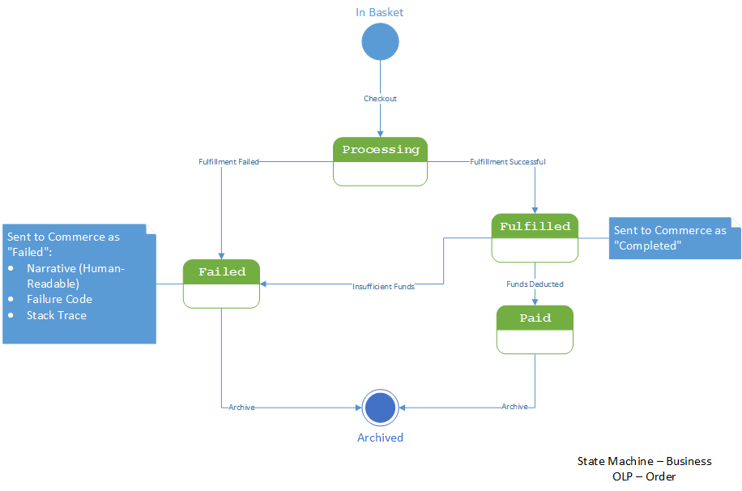

In this diagram the “Processing” state corresponds to work being performed by the Integration Tier. The transition to “Failed” or “Fulfilled” is dictated by the outcome of the Fulfilment / Expiration process.

All other states and transitions are managed by the Web (eBusiness) Tier.

The note on the “Failed” state indicates how Integration Tier error states will be communicated to the user.

## Order Line State Model

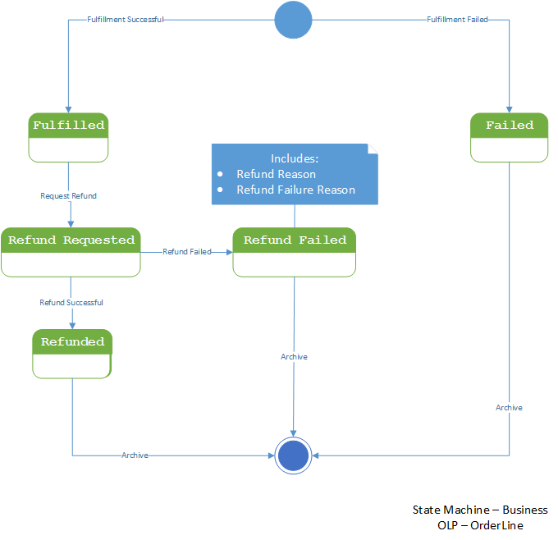

An Order is comprised of Order Lines plus some additional information. When an Order is fulfilled by the Integration Tier, the outcome is that *all* Order Lines are either “Fulfilled” or “Failed”.

Once an Order has been successfully fulfilled, a User may request a refund for a subset of the Order Lines it contained. These refunds either succeed or fail on an individual basis. Orders are not refunded as a whole, although all Order Lines in an Order may be submitted for refund.

As a part of this refund process, the relevant Indicia are sent to LockheedMartin for spoiling. Consequently a User’s Refund request in the Web (eBusiness) Tier produces a Spoil Request to be placed on the Spoil Request queue in the Integration Tier. This Spoil Request will contain all the Indicia related to the Order Lines for which a refund has been requested.

# Activity Diagrams

## User Activity Diagrams

None at this time.

## Integration Tier Activity Diagrams

The following pair of activity diagrams illustrate the operations of the Integration Tier and back-end / 3rd Party Systems (“IndiciaService”, the LockheedMartin replacement and Adobe LiveCycle – indicated by name in activity steps).

### Process / Expire Fulfilment Request Activity Diagram

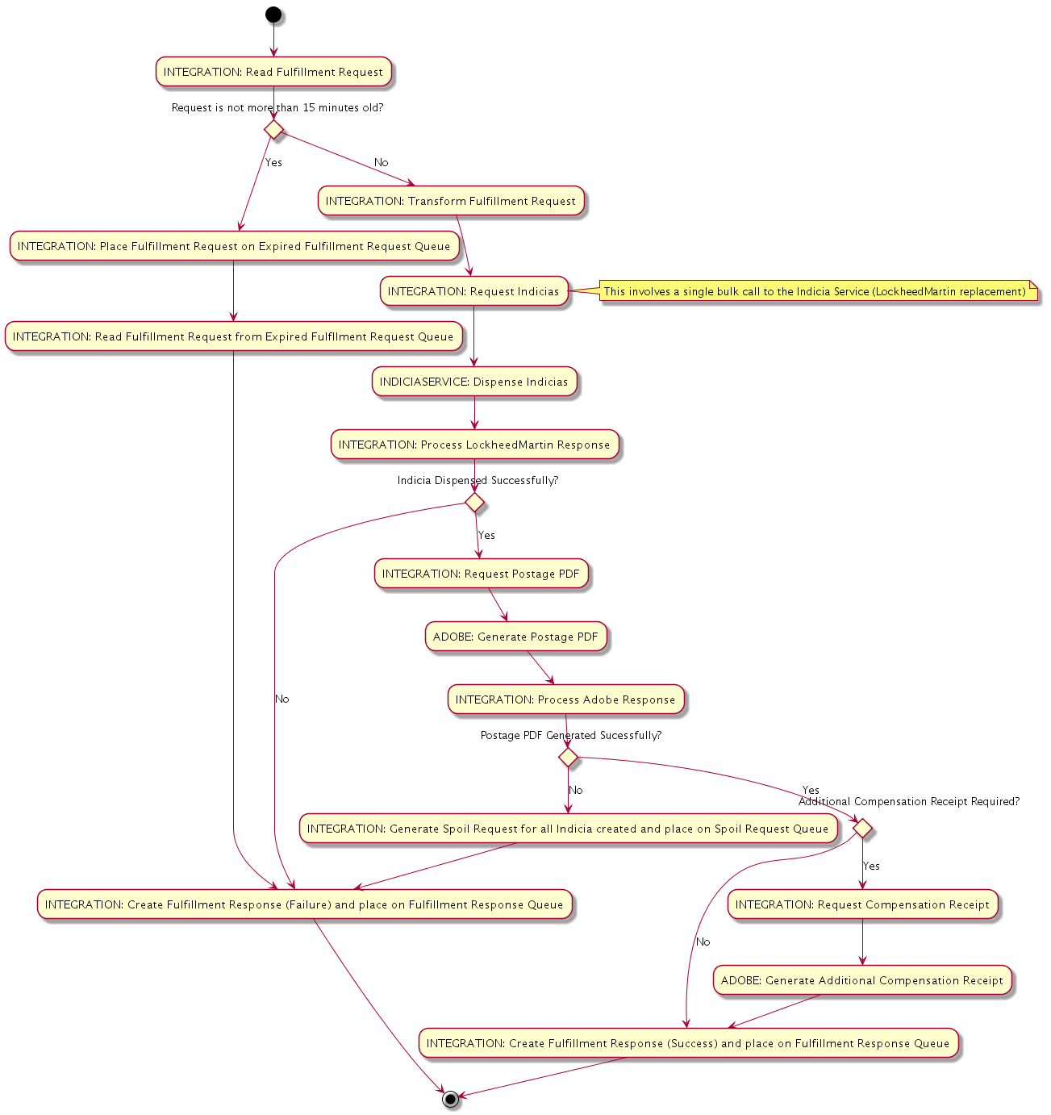

This flow begins when a Fulfilment Request message is placed on the Fulfilment Request queue. It ends when a Fulfilment Response message is placed on the Fulfilment Response queue. Additionally, if subsequent Adobe Label generation fails, a Spoil Request message is placed on the Spoil Request queue.

Processing of Spoil requests is covered in section 7.2.2 below.

### Process Spoil Request Activity Diagram

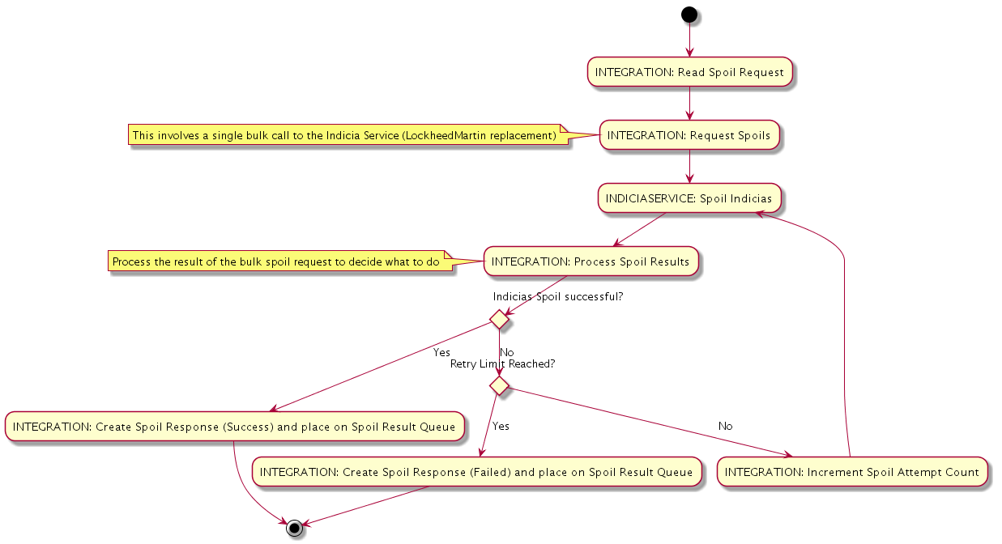

This flow begins when a Spoil Request message is placed on the Spoil Request queue. It ends when a Spoil Response is placed on the Spoil Response queue.

Note that not all Indicia may be spoiled successfully. The Spoil Response however is persistent, and this may be used for later manual reconciliation.

# Enterprise Integration Diagrams

## Process / Expire Fulfilment Request E.I. Diagram

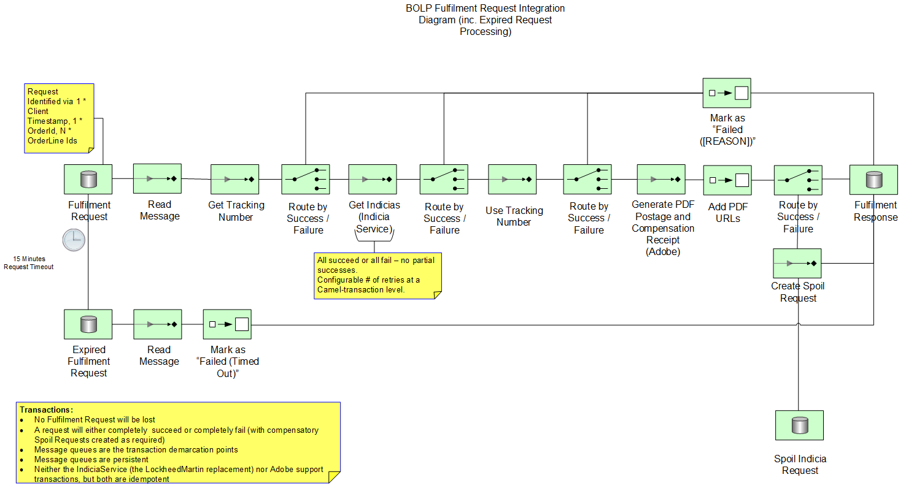

This EIP diagram corresponds directly with the equivalent Activity Diagram in section 7.2.1 above. Its purpose is to illustrate in greater detail the various Camel components which will be used to implement this functionality.

Additionally notes on message IDs, message persistence, transaction boundaries and retries are included.

## Process Spoil Request E.I. Diagram

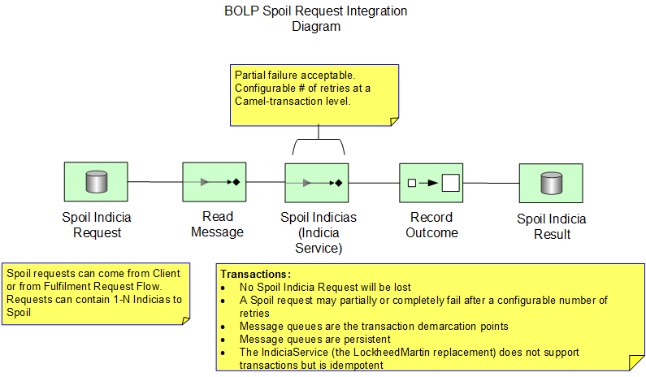

This EIP diagram corresponds directly with the equivalent Activity Diagram in section 7.2.2 above. Its purpose is to illustrate in greater detail the various Camel components which will be used to implement this functionality.

Additionally notes on message persistence, transaction boundaries and partial retries are included.

The Spoil Indicia Request and Spoil Indicia Result queues are exposed to the Web (eBusiness) Tier. However the Fulfillment Request flow shown in section 8.1 above may also place messages on the Spoil Request queue.

# Business OLP User Journeys

## B-OLP Landing Page

The purpose of the B-OLP landing page is to act as an initial point of reference for the user in their B-OLP journey. The B-OLP landing page will contain the journey option panel from which the user is able to select the relevant B-OLP journey, mast head and footer, tooltips and quick links.

### Mast head and footer

The purpose of the Mast head in particular and footer is to provide a simple and easy to way for users to log in, register or navigate back to the Royal Mail home page. This will be present on all pages related to B-OLP journeys.



#### **Mast head and footer**

As a user I want to click on the Royal Mail logo from any B-OLP page and be directed back to the Royal Mail Home Page.

|  |  |
| --- | --- |
| Validation Criteria | |
| VC1 | If a user clicks the Royal Mail logo displayed on the masthead of the B-OLP website from any page they will be returned to the Royal Mail homepage. |

#### **Log in or Register**

As a user I want to click on the log in link and be presented with the Log in window where I am able to input my details

As a user I want to click on Register and be directed to the standard Royal Mail registration page



|  |  |
| --- | --- |
| Business Rules | |
| BR1 | **Log in**  The user is able to log in at any point during the B-OLP journeys. The user is also able to access the B-OLP services up until the checkout process without logging in, however at this stage to progress they will be required to log in or continue as a guest user.  (Guest access to be defined as per pending CR) |

|  |  |
| --- | --- |
| Validation Criteria | |
| VC2 | If a user clicks on the Log in link they will be presented with the log in options as per the B2B portal (reference B2B log in process) |
| VC3 | If a user clicks on the Register link they will be directed to the registration process as per the B2B portal (reference B2B registration process) |

### Journey Options Panel

The purpose of the Journey Options Panel is to act as a starting point from which the user is able to select one of the two B-OLP journeys. The panel consists of links to the two postage journeys which include; (1) Postage Only and (2) Postage and address.

As a user I want to click on Postage Only which will begin this journey by initially directing me to the Price Finder landing page.

As a user I want to click on Postage and address which will begin this journey by initially directing me to (pending review of journey flow).

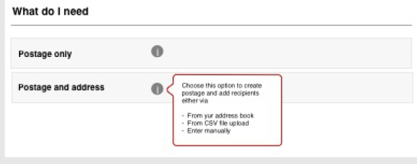

|  |  |
| --- | --- |
| Validation Criteria | |
| VC4 | If I click on the Postage Only link I am directed to the Price Finder landing page. With this journey I will see the following options on the Price Finder landing page:   * Quantity * Which country are you sending your item to? * My item is a... * My item weighs no more than * When you would like your item to arrive? * Value of your item(s)? * Delivery confirmation required? |
| VC5 | If I click on the Postage and address link I am directed to (pending review of journey flow). |

### Tooltips

The purpose of the tooltips throughout the B-OLP application is to provide the user with additional information to help them with their selection. The tooltips are activated when the user hovers over the icon which is located adjacent to the option they require more information about. The tool tip is then presented in a small pop up window.



|  |  |
| --- | --- |
| Validation Criteria | |
| VC6 | If I hover over the tooltip icon adjacent to the Postage only option a small pop up window will appear with the text as per the wireframes |
| VC7 | If I hover over the tooltip icon adjacent to the Postage and address option a small pop up window will appear with the text as per the wireframes |

### Quick Links

To be included in following sprints

## Postage only journey

The purpose of the Postage only journey is to allow the user to purchase postage without the inclusion of specific addresses. Here the user focuses on specifying the quantity of postage items required. The journey covers inputting details to obtain matching products and prices, adding the required products to the users basket, specifying printing formats and options, having the option of including logos and return addresses, and finally checking out and downloading the postage products.

### Price Finder landing page (Postage only)

The purpose of the Price finder landing page for the postage only journey is to allow the user to enter their postage requirements. Here the user is able to enter details around quantity of stamps required, which country the item is being sent to, the PIP type, the weight of the item, when the item is required to arrive, the value of the item and if a proof of delivery is required.

#### **Enter the quantity of stamps required**

As a user I want to enter a quantity for the number of stamps required.

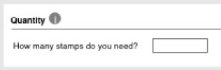

|  |  |
| --- | --- |
| Business Rules | |
| BR2 | **Maximum Quantity**  The user is only allowed to input a maximum quantity of 200 for the required number of stamps |
| BR3 | **Numerical Validation**  The field will only accept whole numerical value. Alpha characters will not be accepted. If the user enters alpha characters, these will be cleared from the field. Numbers entered should be greater than zero and the user will not be able to proceed unless they have provided a numeric value. |
| BR4 | **Mandatory Field**  This is 1 out of the 5 mandatory inputs required. This input can be completed in any order however the user is unable to proceed until all have been completed. |

|  |  |
| --- | --- |
| Validation Criteria | |
| VC8 | If I enter a value greater than 200 then MSG1 should be displayed and I will not be able to continue until the amendments have been made |
| VC9 | If I enter a decimal value or an alpha character then MSG2 should be displayed and I will not be able to continue until the amendments have been made |

|  |  |
| --- | --- |
| Error Messages | |
| MSG1 | You have exceeded the maximum number of stamps. Please amend your quantity to no more than 200 in total |
| MSG2 | Only whole numbers are allowed and no alpha characters may be included. Please amend your entry |

#### **Select the country which the item is being sent to**

As a user I want to select the country which the item is being sent to.

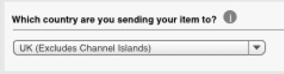

|  |  |
| --- | --- |
| Business Rules | |
| BR5 | **Country List**  The available lists of countries are those provided by the country data configured in BigMachines. |
| BR6 | **PIP Choices**  Based on the country selected the PIP type options will be limited based on the data configured in Big Machines which is retrieved via the Camel PIP types API.  If the UK is selected the following options will be selectable by the user;   * Letter * Large letter   If a destination other than the UK is selected the following will be the only option for the user and will be auto selected;   * Letter (Large letter will not be visible to the user) |
| BR7 | **Sort Order**  The UK is set as the default option for the country list  The drop down list of countries is to be sorted in an alphabetical order (A-Z) |
| BR8 | **Mandatory Field**  This is 1 out of the 5 mandatory inputs required. This input can be completed in any order however the user is unable to proceed until all have been completed. |

#### **Select the PIP type**

As a user I want to select the PIP type of the postage item.

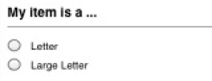

|  |  |
| --- | --- |
| Business Rules | |
| BR9 | **PIP Choices**  See [BR6] |
| BR10 | **Default View**  As the UK is the default country option the following PIP options will be presented to the user as a default:   * Letter * Large Letter   *Note: Neither option will be selected as a default |
| BR11 | **Mandatory Field**  This is 1 out of the 5 mandatory inputs required. This input can be completed in any order however the user is unable to proceed until all have been completed. |

|  |  |
| --- | --- |
| Validation Criteria | |
| VC10 | If I have selected UK from the country list I should only be able to select Letter and Large Letter. |
| VC11 | If I have selected any other country apart from the UK from the country list the option of Letter will be auto selected. The other options will not be visible. |

#### **Enter item weight**

As a user I want to enter the weight of my postage item.



|  |  |
| --- | --- |
| Business Rules | |
| BR12 | **Numerical Validation**  The field will only accept numerical values and decimal points. Alpha characters will not be accepted. If the user enters alpha characters, these will be cleared from the field. Numbers entered should be greater than zero and the user will not be able to proceed unless they have provided a numeric value. |
| BR13 | **Grams**  As this is Postage Only and this journey will only allow the user to select letters, the option will be set to Grams and Kilograms will not be selectable |
| BR14 | **Weight Bands**  The following weight bands are applicable  - Letters 1 to 100g  - Large Letter 1 to 750g TBC |
| BR15 | **Mandatory Field**  This is 1 out of the 5 mandatory inputs required. This input can be completed in any order however the user is unable to proceed until all have been completed. |

|  |  |
| --- | --- |
| Validation Criteria | |
| VC12 | If I have selected the PIP type option of "Letter" and I enter a weight greater than 100g the option will automatically change to "Large Letter" and display MSG3.  The user will remain on the screen and as the option has been automatically changed, they can either choose to continue with the new option of “Large Letter”, amend the value and re select the PIP type of “Letter” or select “back” returning them to the B-OLP landing page from which they can select another journey. |
| VC13 | If I have selected the PIP type option of "Large Letter" I will be restricted to entering a weight up to 750g. If I enter a weight greater than this I will be shown MSG4  The user will remain on the screen and will not be able to proceed until the weight has been amended. The user is also able to select “back” returning them to the B-OLP landing page from which they can select another journey. |

|  |  |
| --- | --- |
| Error Messages | |
| MSG3 | We have changed the size format because your item is too heavy for your initial format selection |
| MSG4 | You have exceeded the weight limit for this selection. Please amend your order |

#### **Select when the item is required to arrive**

As a user I want to be able to select when the postage item is to arrive.

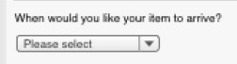

|  |  |
| --- | --- |
| Business Rules | |
| BR16 | **List options**  If the user has selected the UK they are able to select from the following options presented in the following sort order;  - Please Select (default option)  - Next Day  - Within 2-3 days  - Within 5 days  - Within 10 days  - Within 30 days  If the user has selected the any other country apart from the UK they are able to select from the following options presented in the following sort order;  - Please Select (default option)  - Next Day  - Within 2-3 days  - Within 5 days  - Within 10 days  - Within 30 days  - Within 60 Days |
| BR17 | **Mandatory Field**  This is 1 out of the 5 mandatory inputs required. This input can only be completed once a country has been selected. This input will not be selectable until a country has been selected. |

#### **Select the value of the item**

As a user I want to be able to select the value of my postage item



|  |  |
| --- | --- |
| Business Rules | |
| BR18 | **List options**  Selecting value of the item is optional and not dependant on any other input being completed first. If no selection is made the results will be shown based on the other criteria with their standard compensation levels.  The user can select an item value from a drop down list of available options. This will be used to determine products with the following compensation amounts. The list is presented with the following options with the following sort order:  - Don't know (default option)  - Less than £20  - £20  - £50  - £100  - £150  - £250  - £500  - £1000  - £2500 |

#### **Requiring Proof of Delivery**

As a user I want to be able to select if proof of delivery is required so that when presented with the results trackable, recorded, and signed for services will be included.



No validation criterion applicable as this is a check box which is optional allowing user to proceed with or without selecting this.

# Monitoring and Logging

Standard RMG monitoring and logging approaches will be followed.

# Data Retention

Data retention follows the eBusiness data retention policy for eCommerce applications. This includes draft applications that have not been sent.

_______________________________

# APPENDICES

_______________________________

## Appendix A: Abbreviations and Glossary

A list of all shortened forms of words used in the document;

|  |  |
| --- | --- |
| **Abbreviation** | **Description** |
| B-OLP | Business Online Postage |
| RMG | Royal Mail Group |

## Appendix B: Document Control

**Version History**

|  |  |  |  |
| --- | --- | --- | --- |
| **Version** | **Date** | **Produced by / Updated by** | **Comments** |
| v.0.1 | 27th June, 2013 | Andrew Harmel-Law | First draft for internal review |
| v.0.2 | 28th June, 2013 | Andrew Harmel-Law | Second draft incorporating feedback from v.0.1 distribution plus Legend Diagram |
| v.0.3 | 28th March, 2014 | Andrew Harmel-Law | Third draft incorporating changes resulting from the design work for the Barcodes For All Parcels project (specifically the LockheedMartin replacement element) |
| v.04 | 1st May, 2014 | Amar Bharaj | Fourth draft including Business User Journeys from first two sprints |
| V.05 | 2nd May | Amar Bharaj | Draft including comments from internal review |

**Document Distribution**

|  |  |  |  |
| --- | --- | --- | --- |
| **Date** | **Author** | **Version** | **Change Reference** |
|  |  |  |  |
|  |  |  |  |
|  |  |  |  |
|  |  |  |  |

**Document Reviewed By**

|  |  |  |
| --- | --- | --- |
| **Date** | **Name** | **Responsibility** |
| 27th June, 2013 | Charlie Darkins | Engagement Manager |
| 27th June, 2013 | Paul Richards | Enterprise Architect |

**Document <Signed Off By>**

|  |  |  |
| --- | --- | --- |
| **Date** | **Name** | **Responsibility** |
|  |  |  |
|  |  |  |
|  |  |  |
|  |  |  |

## Appendix C: Reference Documents

|  |  |  |  |  |
| --- | --- | --- | --- | --- |
| **Reference No** | **Author** | **Version** | **Date** | **Document** |
|  |  |  |  |  |

## Appendix D: Screen Validations

None at this time.